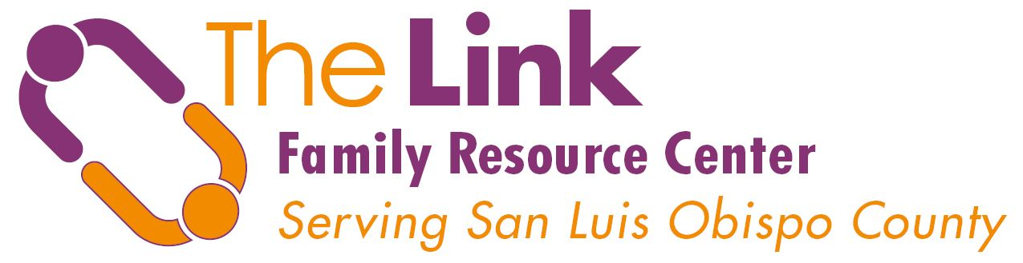
Family Advocate Referral Form
4507 Del Rio Avenue #1, Atascadero, CA 93422
1802 Chestnut Street, Paso Robles, CA 93446
Direct (805) 794-0217 | Fax (805) 462-8901
Fax or email Family Advocate Services Director,
Carrie Collins carrie@linkslo.org

Child Referred: D.O.B Date:

Parent/Caretaker:

Address: Telephone:

School: Grade:

Language: English Spanish Other Family notified of referral: Yes No
Child’s Name /DOB/School Site:
Child’s Name /DOB/School Site:
Child’s Name /DOB/School Site:
Child’s Name /DOB/School Site:
Child’s Name /DOB/School Site:
Child’s Name /DOB/School Site:

Person making the Referral: Agency:

Phone & Email of Person Making the Referral:

Purpose of Referral (check):
0-5 Children Emotional/Behavioral
Academic Physical/Material Needs Homelessness

Additional Comments/Information:

Interventions That Have Been Tried:

Bilingual Education Title 1 Referrals
Alternative School SST/FST/THT Learning Center
School Counseling Special Education
Others:

Confirmed with referring party? Date:

